Elizabeth (Heiptley) Stults
April 16, 1868 – September 4, 1942

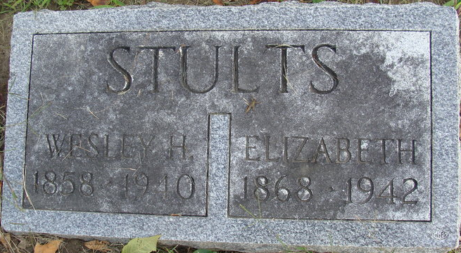
Photo by Alicia Kneuss

Mrs Elizabeth Stults
in the Indiana, U.S., Death Certificates, 1899-2011
Name: Mrs Elizabeth Stults
[Mrs Elizabeth Heiptley]
Gender: Female
Race: White
Age: 74
Marital status: Widowed
Birth Date: 16 Apr 1868
Birth Place: Crawford Co Ohio
Death Date: 4 Sep 1942
Death Place: Rural, Adams, Indiana, USA
Father: Rudolph Heiptley
Mother: Anna Werden
Spouse: Wesley H Stults
Informant: Mrs. Justine Lautenschleger; Decatur, Indiana
Burial: September 8, 1942; Decatur Cemetery; Decatur, Indiana

