Carrie (Schrank) Stults
September 29, 1869 – December 17, 1955

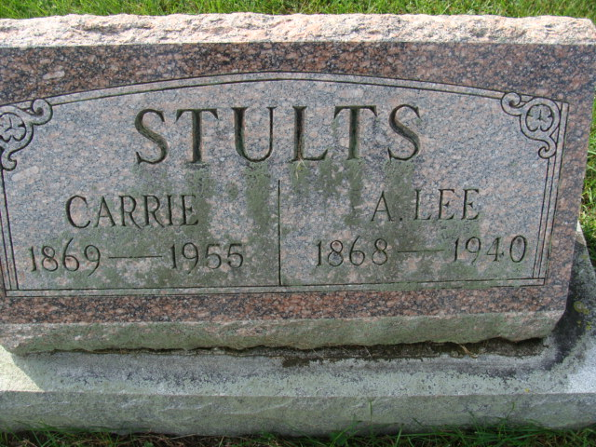
Photo by Alicia Kneuss

Mrs. Carrie Stults Is Taken By Death
Funeral Services Tuesday Afternoon

Mrs. Carrie Stults, 86, a lifelong resident of Adams county, died Saturday afternoon at the Berne nursing home. She had been in failing health since last March and in critical condition for a week. Born in Adams county Sept. 29. 1869. she was a daughter of John and Mary Ellen Schrank, and was married to Alva Lee Stults in 1893. Mr. Stults died July 7. 1940. Mrs. Stults was a member of the First Presbyterian church and the Order of Eastern Star. Surviving are three sons, John Stults. with whom she had made her home for 14 years, Harry L. and George W. Stults, all of Decatur; two grandchildren and four great-grandchildren. Four brothers and one sister preceded her in death. Funeral services will be conducted at 2 p. m. Tuesday at the Black funeral home, the Rev. Ray J. Walther officiating. Burial will he in the Decatur cemetery. Friends may call at the funeral home until time of the services.

Decatur Daily Democrat, Adams County, Indiana
Monday, December 19, 1955
**

Indiana, U.S., Death Certificates, 1899-2017

Name Carrie Stults
[Carrie Shrank]
Gender Female
Race White
Marital Status Widowed
Age 86
Birth Date 29 Sep 1869
Birth Place Adams County, Indiana
Death Date 17 Dec 1955
Death Place Berne, Adams, Indiana, USA
Death Registration Date 1955
Father Can't read
Mother Unknown
Informant John Stults; Decatur, Indiana
Burial December 20, 1955; Decatur Cemetery; Decatur, Indiana

