Blanche May Stults
April 24, 1908 – August 14, 1909

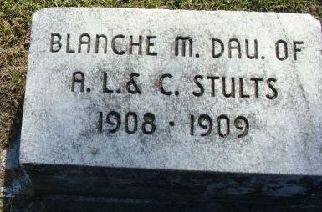
Photo by Alicia Kneuss

Blanch Way Stutts
in the Indiana, U.S., Death Certificates, 1899-2017

Name Blanch May Stutts
Gender Female
Race White
Marital Status Single
Age 1
Birth Date 24 Apr 1908
Birth Place Decatur, Indiana
Death Date 14 Aug 1909
Death Place Decatur, Adams, Indiana, USA
Death Registration Date 1909
Father Alva Lee Stultz
Mother Carrey Schrank
Informant Alva Lee Stultz; Decatur, Indiana
Burial August 16, 1909; Maplewood Cemetery

