Beverly Lou Stults
March 11, 1929 – March 29, 1929

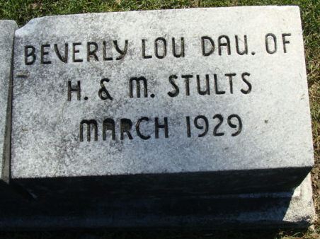
Photo by Alicia Kneuss

Beverly Jov Stults
in the Indiana, U.S., Death Certificates, 1899-2017

Name Beverly Lou Stults
Gender Female
Race White
Marital Status Child
Age 18 days
Birth Date 11 Mar 1929
Birth Place Adams Co
Death Date 29 Mar 1929
Death Place Washington, Adams, Indiana, USA
Death Registration Date 1929
Father Harry L. Stults
Mother Mary E Aurand
Informant Harry Stults
Burial March 31, 1929; Maplewood Cemetery

