Anita Lucile (Stoddard) Stults
June 7, 1914 – May 24, 2009

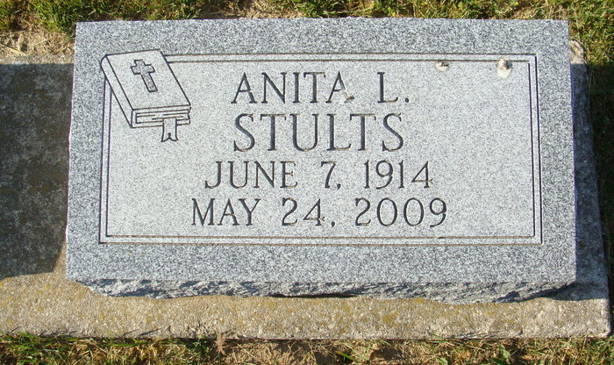
Photo by Alicia Kneuss

Anita Lucile Stoddard
in the Indiana, U.S., Marriages, 1810-2001

Name Anita Lucile Stoddard
Gender Female
Race White
Age 32
Event Type Marriage Registration (Marriage)
Birth Date 7 Jun 1914
Birth Place Atlanta, Indiana
Marriage Date 18 Jan 1946
Marriage Place Fort Wayne, Indiana, United States
Residence Place Fort Wayne, Allen, Indiana
Father John Wells Stoddard
Mother Christena Anna King
Spouse Thrueman Wayne Stults
Page 171
**

U.S., Social Security Death Index, 1935-2014

Name Anita Stults
Social Security Number xxx
Birth Date 7 Jun 1914
Issue year Before 1951
Issue State Indiana
Last Residence 48180, Taylor, Wayne, Michigan
Death Date 24 May 2009

