Alma F. (Brown) Stults
August 19, 1895

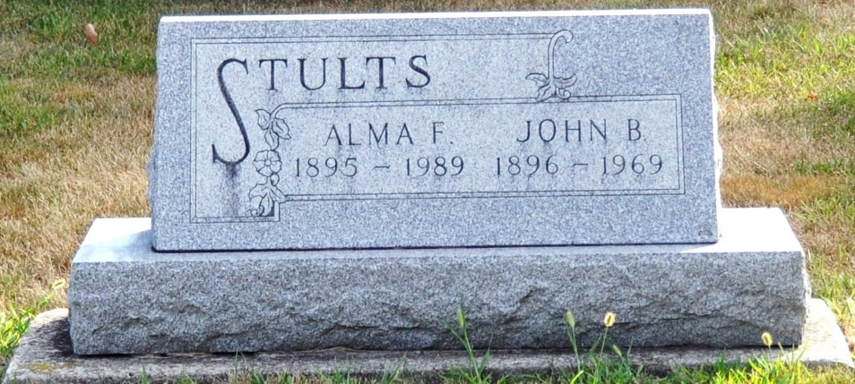
Photo by Deb Curry

Alma F Stults
in the Indiana, U.S., Death Certificates, 1899-2017

Name Alma F Stults
[Alma F Brown]
Gender Female
Race White
Marital Status Widowed
Age 93
Birth Date 19 Aug 1895
Birth Place Decatur, Indiana
Death Date 29 Mar 1989
Death Place Fort Wayne, Allen, Indiana, USA
Death Registration Date 1989
Father Samuel Brown
Mother Edna Peoples
Informant William Brown; nephew; Decatur, Indiana
Burial April 1, 1989; Decatur Cemetery; Decatur, Indiana

