Elizabeth B. (Wilkie) Stueber
October 8, 1897 – December 26, 1972

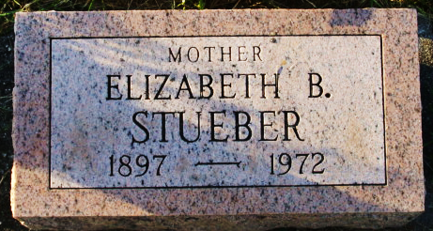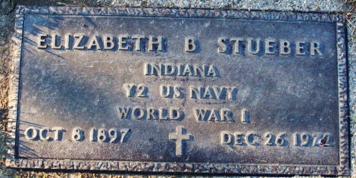
Photo by Alicia Kneuss

Elizabeth Stueben [sic] Dies this Morning
Mrs. Elizabeth B. Stueben, 75, of 341 South Fifth Street, widow of Ralph Stueben, died at 2 a.m. today at the Parkview Memorial Hospital, Fort Wayne, following an extended illness.
Mrs. Stueben was a retired office employee and a member of the Presbyterian Church, the American Legion, and was a World War I Navy veteran. She was born in Boston, Mass., on October 8, 1897, the daughter of David and Margaret Boyd-Wilkie, and was married to Ralph Stueben on April 4, 1920. Her husband preceded her in death in 1960.
Surviving are one daughter, Mrs. Jack S. (Mildred E.) Knudsen of Decatur; one sister, Mrs. Eleanor Ross of Plymouth, N.H.; and four grandchildren.
Funeral services will be conducted at 1 p.m. Wednesday at the Winteregg-Linn Funeral Home, with Rev. Robert VanderHart officiating. Burial will be in the Decatur Cemetery. Friends may call at the funeral home after 7 p.m. tonight.

Decatur Daily Democrat, Adams County, Indiana
Tuesday, December 26, 1972

