David E. Studabaker
July 16, 1871 – October 1, 1925

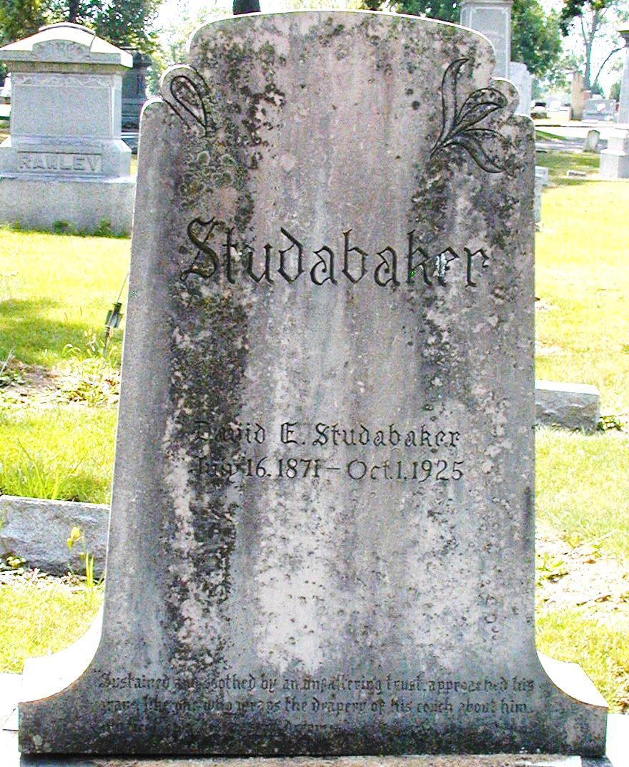
Photo by Steve

David E. Studabaker
in the Indiana, U.S., Death Certificates, 1899-2017
Name David E. Studabaker
Gender Male
Race White
Marital Status Married
Age 54
Birth Date 16 Jul 1871
Birth Place Decatur
Death Date 1 Oct 1925
Death Place Fort Wayne, Allen, Indiana, USA
Death Registration Date 1925
Father David Studabaker
Mother Harriett Evans
Spouse Marian
Informant Mrs. David E. Studabaker; Decatur, Indiana
Burial October 4, 1925; Decatur, Indiana

**
DAVID E. STUDABAKER.
David E. Studabaker, one of the large landowners and stock growers of Adams County, is the son and youngest child of the Hon. David Studabaker, whose name is indelibly written in the history of the development of Adams County and who has left a lasting impression on the entire northeastern section of the state.
The son of this illustrious father was born on the parental farm in Adams County, near the city of Decatur, July 16, 1871. He is one of a family of six children born to David and Harriet (Evans) Studabaker. He spent his youth on his father's farm and was educated in the schools of his neighborhood and in Decatur. After completing his preliminary education in the common schools he studied for a time in the Howe grammar school at Lima, Indiana, and later at the Kenyon Military School at Gambier, Ohio.
After he left this latter school he entered the employ of the Niblick & Company store at Decatur and worked for this mercantile establishment for one year. He then entered the Adams County Bank as a bookkeeper and served that financial institution in this capacity for six and one half years. Following the severance of his relations with the bank he engaged in the fire insurance business in Decatur. He represented the farmer department of the Home Insurance Company of New York in Adams, Allen, Wells and Jay Counties for two years and was successful in conducting the affairs and business of his employing company in these counties. After giving up the fire insurance business he went to Fort Wayne and secured employment with M. S. and W. J. Vesey, the well known florists. While in the employ of these men he was assistant rosegrower and remained in the employ of the Veseys for one and one half years.
At the outbreak of the Spanish-American war Mr. Studabaker enlisted in the newly organized Battery E, Light Artillery, and served with this command during the term of its service. The battery saw no active service and did not leave the country. When the battery was mustered out of service he returned to Fort Wayne but soon went to Decatur and engaged as a bookkeeper with the Adams County Bank. He remained with the bank for three years and then retired to his father's farm in Washington township and assisted in its management. After his father's death, May 3, 1904, Mr. Studabaker succeeded to the ownership of the farm and has since been actively engaged in its management.
This farm consists of seven hundred and forty acres of fine land. It is improved and has been brought to a high point of productiveness and cultivation. In fact, it is one of the finest as well as one of the largest estates in the county. The land is fertile and well drained and fenced and the buildings, including the residence and barns, are modern, large and admirably adapted to meet the purposes to which, they are put.
The marriage of Mr. Studabaker and Miss Lucy A. Beane occurred at Goshen, Indiana, November 25, 1891. Mrs. Studabaker is a daughter of the late William A. and Sarah E. (Mercer) Beane, of Goshen, Indiana. The former was editor and proprietor of the Goshen Democrat. One child, a son, David B. Studabaker, has been born of the union, October 5, 1892.
Mr. Studabaker is one of the most extensive farmers and stock-raisers of Adams County. He makes a specialty of registered Duroc-Jersey swine and of fine grades of cattle. His strains of hogs and cattle are numbered among the best in the county. He is enthusiastic in fraternal matters and is a member of the Elks Lodge, No. 993, of Decatur, of which he has been secretary and is now esteemed lecturing knight; Decatur Lodge, No. 167, Independent Order of Odd Fellows, and of Odd Fellows Encampment, No. 214.

Snow's History of Adams County, Indiana, John Fletcher Snow, B. F. Bowen, Indianapolis, IN, 1907

