David B. Studabaker
October 5, 1893 – September 6, 1934

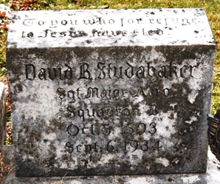
Photo by Deb Curry

David B. Studabaker
in the Indiana, U.S., Death Certificates, 1899-2017
Name David B. Studabaker
Gender Male
Race White
Marital Status Married
Age 40
Birth Date 5 Oct 1893
Birth Place Adams County
Death Date 6 Sep 1934
Death Place Decatur, Adams, Indiana, USA
Death Registration Date 1934
Father David E Studabaker
Mother Lucy Beane
Spouse Mary Smith
Informant Mrs. Hattie Obenauer; Decatur, Indiana
Burial September 9, 1934; Decatur Cemetery

