Ruby Roselyn (Foreman) Stucky
March 21, 1916 – July 8, 2008

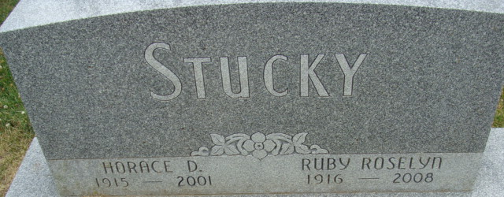
Photo by Alicia Kneuss

Ruby "Rosey" Stucky, 92 of Swiss Village Nursing Center, formerly of Decatur died on Tuesday, July 8, 2008 at Adams Memorial Hospital.
She was the daughter of the late Manley Foreman and Lessie O Teeter. Rosey was born on March 21,1916 in Decatur, Indiana. She married Horace D. Stucky on Oct. 1, 1938 he died Dec. 2001.
She is survived by a brother-in-law Orlyn Master of Rochester, IN and several nieces and nephews.
Rosey was a member of the First Presbyterian Church in Decatur and was in the Quarter Century Club. She worked for General Electric for 26 years.
A graveside service will be held on Friday, July 11, 2008 at 2:00 pm at the Decatur Cemetery with calling 1/2 hour prior to services at the cemetery. Rev. Laura Sherwood will be officiating. Memorials are to First Presbyterian Church.

Haggard-Sefton & Hirschy Funeral Home, Adams County, Indiana
July 9, 2008

**
Indiana, U.S., Death Certificates, 1899-2017
Name Ruby R Stucky [Ruby R Foreman]
Gender Female; Race White
Marital Status Widowed
Age 92
Birth Date 21 Mar 1916; Birth Place Decatur, Indiana
Death Date 8 Jul 2008; Death Place Decatur, Adams, Indiana, USA
Death Registration Date 2008
Father Manley Foreman
Mother Lessie O Teeter
Informant Larry Liechty; nephew; Berne, Indiana
Burial Decatur Cemetery; Decatur, Indiana

