Patricia A. (Campbell) Stucky
March 11, 1933 – October 17, 2015

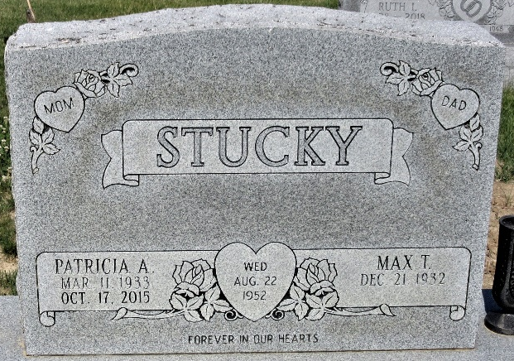
Photo by PLS

Patricia A. Stucky, 82, of Angola, passed away Saturday, Oct. 17, 2015 at Parkview Regional Medical Center. Patricia was born March 11, 1933, in Van Wert County, Ohio, to the late Frederick and Bertha (Hundley) Campbell. On Aug. 22, 1952, she married Max Ted Stucky. Patricia was a member of the Presbyterian Chapel of the Lakes in rural Angola.
She was a homemaker and was also a nurse’s aide for 14 years at Adams County Memorial Hospital. Patricia was a 1952 graduate of Van Wert High School.
Patricia is survived by her husband of 63 years, Max Stucky of Angola; a son, Mike (Julie) Stucky of Ft. Wayne; two daughters, Kimela (Scott) Abbott of Huntertown and Debra Bultemeier of Decatur; three sisters, Dorothy Stuckey of Grover Hill, Ohio, Winifred Wilson of Van Wert, Ohio, and Rose (Lester) Merkle of Turkey Lake; seven grandchildren, and seven great-grandchildren and one on the way. She was preceded in death by a son-in-law, Jerry Bultemeier, great-grandson, Gryffin M. Stucky, and sister, Alice Stevens.
Visitation will be from 2-4 and 6-8 p.m. Tuesday, Oct. 20, 2015, at Haggard-Sefton & Hirschy Funeral Home. Funeral service will be held at 10:30 a.m. on Wednesday, Oct. 21, 2015, at the Presbyterian Chapel of the Lakes, 2955 W. Orland Rd, Angola, Indiana, with calling one hour prior to service. The Rev. Tom Smith will officiate. Burial will take place in Decatur Cemetery at 3 p.m.
Memorials are to the Presbyterian Chapel of the Lakes or Parkview Regional Medical Center Hospice & Palliative Care.

Haggard & Sefton Funeral Home, Adams County, Indiana
October 18, 2015

**
Indiana, U.S., Death Certificates, 1899-2017
Name Patricia A Stucky
Maiden Name Campbell
Gender Female
Race White
Age 82
Birth Date 11 Mar 1933
Birth Place Van Wert, Ohio
Death Date 17 Oct 2015
Death Place Fort Wayne, Allen, Indiana, USA
Death Registration Date 2015
Father Frederick Campbell
Mother Bertha Hundley
Spouse Max Ted Stucky
Informant Max Stucky; spouse; Angola, Indiana
Burial Decatur Cemetery; Decatur, Indiana
Certificate Number 049992

