Max T. Stucky
December 21, 1932 – April 17, 2021

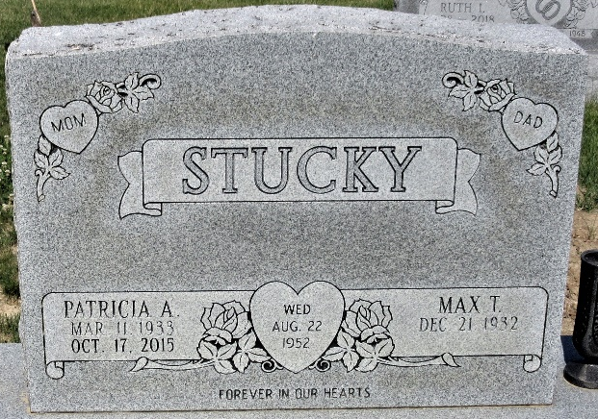
Photo by PLS

Max T. Stucky, 88, passed away peacefully on Saturday, April 17, 2021, at his home on Crooked Lake, Angola, IN. He was born on December 21, 1932 in Berne, IN, the son of the late Florenz and Metta (Nussbaum) Stucky. On August 22, 1952, Max married Patricia A. Campbell and she preceded him in death on October 17, 2015.
He was a 1950 graduate of Geneva High School. Max was a member of the Presbyterian Chapel of the Lakes in Angola. Max worked for Yost Construction for 46 years and did many jobs there over the years including project supervisor and heavy equipment operator. He eventually retired from the renamed Prestress Services in 1995.
Max and Pat bought their home on Crooked Lake in 1974 and cherished their summers with family, until they moved there full-time in the mid 90's. He and his late wife also enjoyed their 10 winters in Port Aransas, TX. He liked deep sea fishing and watching college basketball especially I.U. Max found great joy in helping others and was always willing to sit down and listen to those that needed it.
He is survived by his son, Mike (Julie) Stucky of Fort Wayne; 2 daughters, Kimela (Scott) Abbott of Huntertown and Debra Bultemeier of Decatur; 2 sisters, Ruby Brouer of Stroh and Bonnie Wall of Bluffton; 6 grandchildren and 10 great grandchildren; his beloved poodle, Cindy. He was preceded in death by a son-in-law, Jerry Bultemeier; a grandson, Travis Bultemeier; a great grandson, Gryfin Stucky; 4 brothers and 4 sisters.
A Funeral Service will be held at 2:00 p.m. on Saturday, April 24, 2021 at Haggard-Sefton-Hirschy & Zelt Funeral Home, with calling 3 hours prior to service from 11:00 a.m. – 2:00 p.m. Rev. Tom Smith will be officiating and burial will immediately follow in the Decatur Cemetery.
Memorials may be made to the Presbyterian Chapel of the Lakes or Parkview Home Health & Hospice.

Haggard & Sefton Funeral Home, Adams County, Indiana
April 18, 2021

