Ivan N. Stucky
April 24, 1903 – June 13, 1978

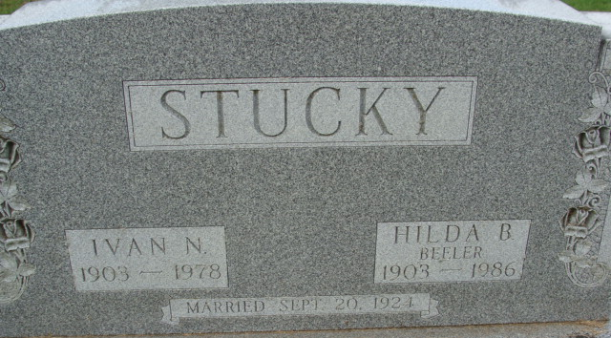
Photo by Alicia Kneuss

Ivan N Stucky
in the Indiana, U.S., Death Certificates, 1899-2017
Name Ivan N Stucky
Gender Male
Race White
Marital Status Married
Age 75
Birth Date 24 Apr 1903
Birth Place Indiana
Death Date 13 Jun 1978
Death Place Decatur, Adams, Indiana, USA
Death Registration Date 1978
Father David Stucky
Mother Barbara Rich
Spouse Hilda B Beeler
Informant Hilda B. Stucky; Decatur, Indiana
Burial June 17, 1978; Decatur Cemetery; Decatur, Indiana

