Horace David Stucky
August 5, 1915 – December 11, 2001

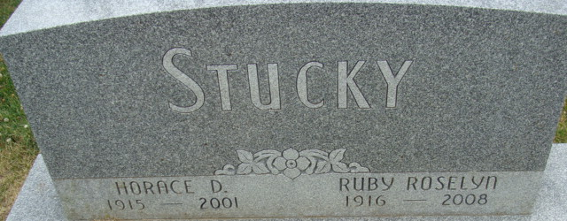
Photo by Alicia Kneuss

Horace David Stucky, 86, of Decatur, a member of First Presbyterian Church, died Tuesday, Dec. 11, 2001, at Adams County Memorial Hospital.
The Berne native retired from Zollner Corp. in Fort Wayne after 32 years of service, and had worked at Smith Brothers Furniture in Berne and at Central Dairy in Fort Wayne.
Surviving is his wife, Ruby R.; and sisters Naomi Liechty of Berne and Edith Musser of Bluffton. He was preceded in death by a brother, Sherman.
Services are 2 p.m. Friday at Haggard & Sefton Funeral Home, Decatur, with calling from 2 to 4 and 6 to 8 p.m. Thursday. Burial will be at Decatur Cemetery.
Memorials are to the church or the Adams County Heart Club.
News-Sentinel, Allen County, Indiana
Wednesday, December 12, 2001
**
Indiana, U.S., Death Certificates, 1899-2017
Name Horace David Stucky
Gender Male; Race White
Marital Status Married
Age 86
Birth Date 5 Aug 1915
Birth Place Berne, Indiana
Death Date 11 Dec 2001
Death Place Decatur, Adams, Indiana, USA
Death Registration Date 2001
Father Walter Stucky
Mother Ada Lehman
Spouse Ruby R Foreman
Informant Mrs. Ruby Stucky; wife; Decatur, Indiana
Burial December 14, 2001; Decatur Cemetery; Decatur, Indiana

