Hilda B. (Beeler) Stucky
August 15, 1903 – December 15, 1986

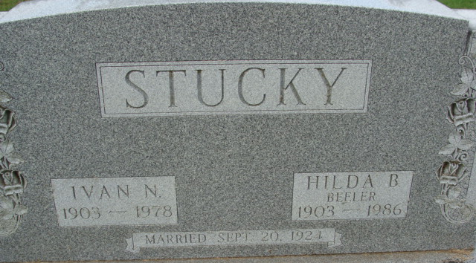
Photo by Alicia Kneuss

Hilda B. Stucky, 83, Swiss Village, Berne, died at 2:14 p.m. Monday at Lutheran Hospital, Fort Wayne. She was a member of St. Mark's United Methodist Church, Keen-Agers and Mary Circle of the church.
Born in Adams County on August 15, 1903, she was the daughter of Fred and Amelia Meshberger-Beeler, and was married on September 20, 1923, to Ivan Stucky; he died June 13, 1978.
Survivors include two sons; Professor Ronald L. Stucky, Los Altos, Ca., and Marvin W. Stucky, Orchard Lake, Mi; one brother, Arthur Beeler, route 3, Decatur; nine grandchildren; and two great-grandchildren. One brother preceded her in death.
Services will be held Thursday at 10:30 a.m. at St. Mark's United Methodist Church, Rev. James Hook officiating. Burial will be in Decatur Cemetery. Friends may call Wednesday at Winteregg-Linn & Haggard Funeral Home from 2-5 and 7-9 p.m., and one hour prior to services at the church Thursday.
Memorials are to the church.

Berne Tri-Weekly News, Adams County, Indiana
Wednesday, December 17, 1986

