F. Lucile (Gay) Stuckey
July 11, 1910 – November 20, 2001

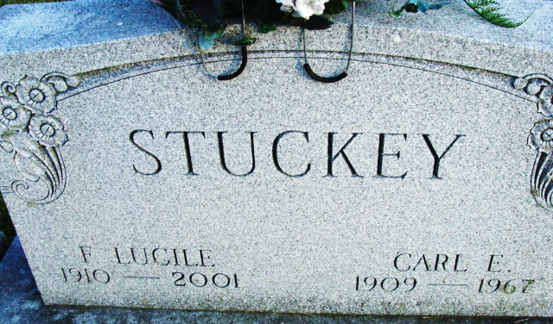
Photo by Deb Curry

Lucile "Mimi" Stuckey, 91, of Decatur, a former member of the Order of Eastern Star, died Tuesday, Nov. 20, 2001, at Adams County Memorial Hospital. The Decatur native was employed with Niblick Store for 35 years and was a member of Zion United Church of Christ.
Surviving is a daughter, Sunya Faurote of Decatur; grandchildren Gary Faurote of Indianapolis, Karla Hormann and Brent Faurote, both of Decatur, and Greta Faurote of Kokomo; and six great-grandchildren. She was preceded in death by her husband, Carl.
Services are 11 a.m. Friday at Haggard & Sefton Funeral Home, Decatur, with calling from 9 a.m. until services. Burial will be at Decatur Cemetery.
Memorials are to the church.

Haggard & Sefton Funeral Home, Adams County, Indiana
November 21, 2001

**
Indiana, U.S., Death Certificates, 1899-2017
Name F Lucile Stuckey
[F Lucile Gay]
Gender Female
Race White
Marital Status Widowed
Age 91
Birth Date 11 Jul 1910
Birth Place Decatur, Indiana
Death Date 20 Nov 2001
Death Place Decatur, Adams, Indiana, USA
Death Registration Date 2001
Father Harvey Gay
Mother Golda Drake
Informant Mrs. Sunya Faurote; daughter; Decatur, Indiana
Burial November 23, 2001; Decatur Cemetery; Decatur, Indiana

