Carl E. Stuckey
August 14, 1909 – June 9, 1967

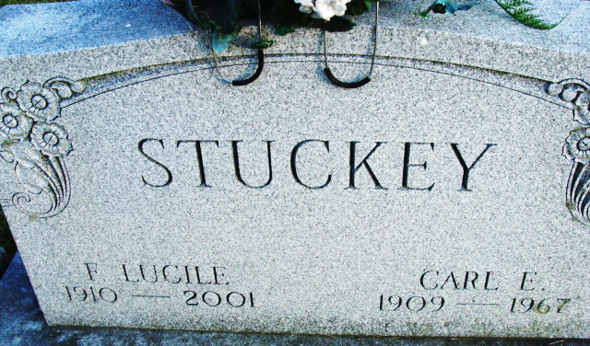
Photo by Deb Curry

Carl E Stuckey
in the Indiana, U.S., Death Certificates, 1899-2017
Name Carl E Stuckey
Gender Male
Race Caucasian (White)
Marital Status Married
Age 57
Birth Date 14 Aug 1909
Birth Place Indiana
Death Date 9 Jun 1967
Death Place Decatur, Adams, Indiana, USA
Death Registration Date 1967
Father C E Stuckey
Mother Caroline Baker
Informant Mrs. Carl E Stuckey; wife; Decatur, Indiana
Burial June 12, 1967; Decatur Cemetery; Decatur, Indiana

