Rev. Dr. Robert K. Stuck
August 11, 1934 -

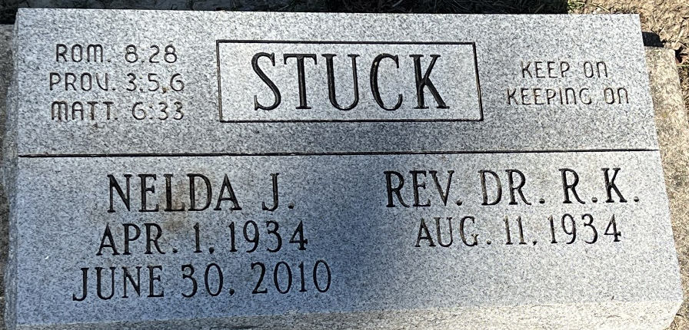
Photo by Deb Curry

