Nelda J. (McPheron) Stuck
April 1, 1934 – June 21, 2010

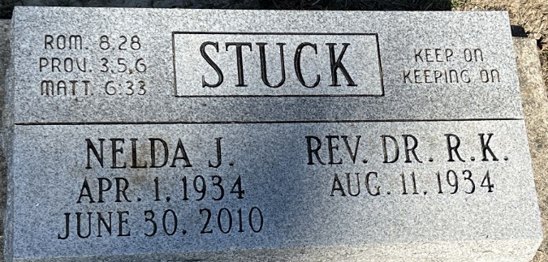
Photo by Deb Curry

Nelda J. Stuck, 76 years old of Huntington, Indiana, passed away at 7:20 a.m. on Monday, June 21, 2010 in the Visiting Nurse & Hospice Home located in Fort Wayne, Indiana.
Nelda was born on Sunday, April 1, 1934 in Lima, Ohio the daughter of the late Charles McPheron and the late Lois (Skinner) McPheron. She married Robert K. Stuck on April 14, 1956 in Dayton, Ohio and he survives.
Nelda was a homemaker, a pastor's wife, and was always very active in the churches that her husband served. Dr. Robert Stuck and Nelda served in the following churches: Freedhem Evangelical Free Church in Freedhem, Minnesota; the Markey Community Baptist Church in Roscommon, Michigan; the Faith Baptist Church in Adrian, Michigan; the Metea Baptist Church in Logansport, Indiana; the First Baptist in Decatur, Indiana 19898-1999; and the Oakdale Baptist Church in Peru, Indiana 1999 to present.
Surviving is her husband, Dr. Robert K. Stuck of Huntington, Indiana; daughter, Kimberly Sue (Dave) Lynn of Lansing, Michigan; daughter, Cindy Lynn (Les) Marckel of Decatur, Indiana; daughter, Dawn Marie (Bryce) Sutton of Monroeville, Indiana; sister, Carol (Victor) Archambeau of Van Wert, Ohio; nine grandchildren, and eleven great-grandchildren.
Preceding Nelda in death were two daughters, Vickie (infancy); Shari Lee Stuck (11 years old); and two brothers, Robert & Richard McPheron.
Funeral services will be held at 11:00 a.m. Thursday, June 24, 2010 in the Oakdale Baptist Church in Peru, Indiana with Rev. Dr. Jim D. Walker officiating. Friends will be received from 9:00 - 11:00 a.m. in the Oakdale Baptist Church in Peru, Indiana and also 6:00 - 7:30 p.m. Thursday in the Zwick and Jahn Funeral Home, Decatur, Indiana with a service at 7:30 p.m. in the funeral home. Nelda's final resting place will be in the Decatur Cemetery, Decatur, Indiana.
Preferred memorials are to Oakdale Baptist Church in Peru, Indiana.

Zwick & Jahn Funeral Home, Adams County, Indiana

