Mildred Avonelle (Beihold) Strouse
May 21, 1918 – March 8, 2005

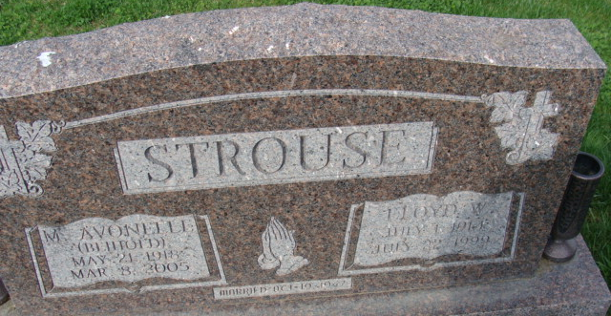
Photo by Alicia Kneuss

Mildred Avonelle Strouse, 86, of Decatur, Adams County, died Tuesday, March 8, 2005, 5:35 a.m., Community North Hospital, Indianapolis. Born May 21, 1918, in Decatur, she was the daughter of the late William Frederick Reihold (sic – Beihold) and Emily Rebecca Henline. She married Floyd W. Strouse on Oct. 19, 1947, in Decatur, who passed away July 22, 1999.
She was a member of Zion Lutheran Church, Decatur. As a young lady she attended Art School, in Fort Wayne, by virtue of a scholarship. She was a homemaker and had worked at a Fort Wayne K-Mart for 20 plus years.
Surviving are daughters, Mrs. John (Connie) Edmondson of Indianapolis and Joye Cole of Glenwood Springs, Colo.; sons, Steven Strouse of Tempe, Ariz., Kenneth Strouse of Decatur and Michael Strouse Texarkana, Texas; sister, Imogene Beihold of Indianapolis; brother, Ed (Marge) Beihold of Indianapolis; sister, Nelvalene Brooks of Pittsburgh, Pa.; 11 grandchildren; and two great-grandchildren. She was preceded in death by three sisters, Vera Goldner, Elizabeth Cook and Olive Cook; and two brothers, Wilmer and Lawrence Beihold.
Service is 10 a.m. Saturday at Zion Lutheran Church, Decatur. Pastor Scott Bruick officiating. Visitation is from 2 to 4 and 6 to 8 p.m. Friday at Zwick & Jahn Funeral Home, Decatur and one hour prior to the service Saturday at the church. Burial at Decatur Cemetery.
Preferred memorials to Zion Lutheran Church or American Lung Association.

News-Sentinel, Allen County, Indiana
Wednesday, March 9, 2005

