Floyd W. Strouse
July 1, 1914 – July 22, 1999

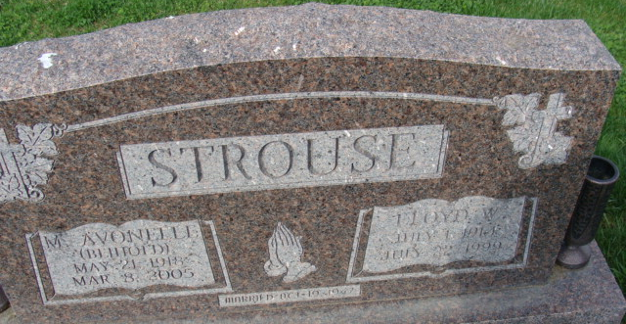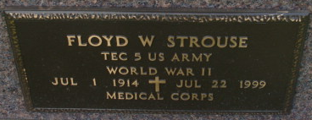
Photo by Alicia Kneuss

Floyd W. Strouse, 85, of Decatur, a retired truck driver, died Thursday, July 22, 1999, at Adams County Memorial Hospital. The Noble County native was retired from Teeple Truck Lines, a member of Wells County Coon Hunters Club and a World War II Army Medical Corps veteran.
Surviving are his wife, Avonelle; daughters Connie Edmondson of Indianapolis and Joye Cole of Glenwood Springs, Colo.; sons Steven of Tempe, Ariz., Kenneth of Decatur and Michael of Maud, Texas; a brother, Marlowe of Goshen; and 11 grandchildren.
He was preceded in death by four brothers and three sisters.
Services are 10 a.m. Monday at Zwick & Jahn Funeral Home, Decatur, with calling from 11 a.m. to 1 p.m. and 3 to 6 p.m. Sunday. Burial with military graveside services will be at Decatur Cemetery.

News-Sentinel, Allen County, Indiana
Friday, July 23, 1999
**
Indiana, U.S., Death Certificates, 1899-2017
Name Floyd W. Strouse
Gender Male
Race White
Marital Status Married
Age 85
Birth Date 1 Jul 1914
Birth Place Noble County, Indiana
Death Date 22 Jul 1999
Death Place Decatur, Adams, Indiana, USA
Death Registration Date 1999
Father Vernon Strouse
Mother Cora Huntsman
Spouse Avonelle Beihold
Informant Avonelle Strouse; wife; Decatur, Indiana
Burial July 26, 1999; Decatur Cemetery; Decatur, Indiana

