Linda B. (Bultemeier) Striker
February 8, 1921 – March 2, 2017

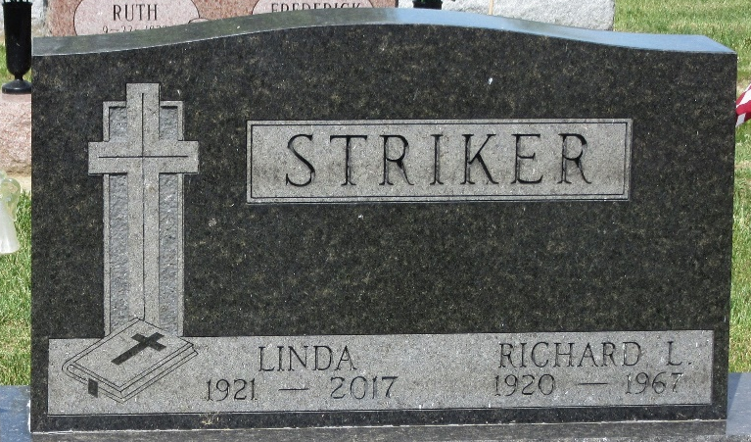
Photo by PLS

Linda B. Striker, 96 years old of Decatur, Indiana, passed away on Thursday, March 2, 2017 at Adams Heritage in Monroeville. She was born on Tuesday, February 8, 1921 in Preble Township, Adams County, Indiana the daughter of the late Herman J. Bultemeier and the late Emma (Kiefer) Bultemeier. She was united in marriage to Richard Loren Striker on August 6, 1949 at Zion Lutheran Church in Decatur and he preceded her in death on September 3, 1967.
Linda was a member of Emmanuel Lutheran Church, Soest in Fort Wayne where she was involved with the Altar Guild and also the Lutheran Women's Missionary League (LWML).
She was employed by General Electric in Decatur for 12 years. She also provided nanny care and domestic assistance for several pastors in the Decatur area. She was a professional seamstress and was a partner in the La Jola Bridal Salon in Decatur. Linda was active in Adams County 4-H where she served as a group leader for over 20 years. Among her many other activities, Linda enjoyed gardening, refurbishing antique furniture, and also upholstery repair, a skill she learned from her husband.
Surviving is her daughter, Emalese S. (Stephen) Adams of West Lafayette, IN; son, Scott S. Striker of Fisher, IL; son, Shawn L. (Donna) Striker of Fort Wayne, IN; sister, Leona Worth of Decatur, IN; brother, Gilbert (Imogene) Bultemeier of Decatur, IN; eight grandchildren; and three great-grandchildren.
Preceding Linda in death was her brother, Gerald Bultemeier and her sister, Erna (Bultemeier) Tuttle.
Funeral services will be held at 11:00 a.m. Monday, March 6, 2017 at Emmanuel Lutheran Church, Soest located at 9909 Wayne Trace in Fort Wayne with Rev. Shayne Jonker officiating. Interment will follow in the Decatur Cemetery. Friends will be received one hour prior to the service at the church on Monday.
Preferred memorials are to Emmanuel Lutheran Church, Soest or Adams Heritage.

Zwick & Jahn Funeral Home, Adams County, Indiana

