Ellen Maybell (Hart) Striker
April 16, 1930 – November 16, 1957

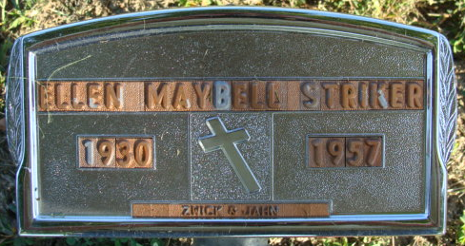
Photo by Alicia Kneuss

Indiana, Death Certificates, 1899-2017
Name Mrs Ellen Maybell Striker
[Mrs Ellen Maybell Hart]
Gender Female
Race White
Age 27
Marital Status Married
Birth Date 16 Apr 1930
Birth Place Indiana
Death Date 16 Nov 1957
Death Place Decatur, Adams, Indiana, USA
Death Registration Date 1957
Father Clifton Hart
Mother unknown
Spouse James Striker, informant
Burial Decatur Cemetery 11-18-1957

**
Indiana, U.S., Marriages, 1810-2001
Name Ellen Mabelle Hart
Gender Female
Race White
Age 18
Event Type Marriage Registration (Marriage)
Birth Date 16 Apr 1930
Birth Place Willshire, Ohio
Marriage Date 3 Jul 1948
Marriage Place Indiana, United States
Residence Place Decatur, Indiana
Father Clifton Hart
Mother Gaynel Secaur
Spouse James William Striker
Page 305

