William C. Strickler
May 8, 1894 – June 14, 1970

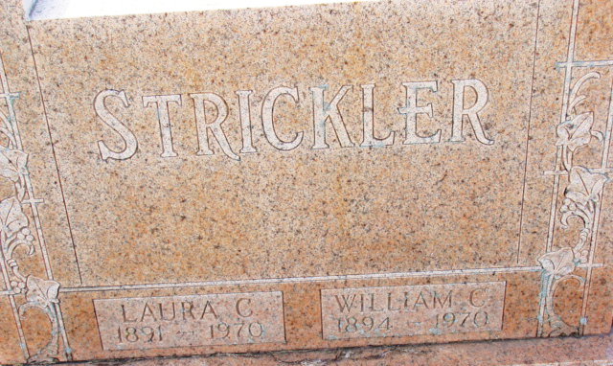
Photo by Alicia Kneuss

William C Strickler
in the Indiana, U.S., Death Certificates, 1899-2017
Name William C Strickler
Gender Male
Race White
Marital Status Married
Age 76
Birth Date 8 May 1894
Birth Place Indiana
Death Date 14 Jun 1970; suicide by rifle
Death Place Portland, Jay, Indiana, USA
Death Registration Date 1970
Father Grant Strickler
Mother Emma Everett
Spouse Laura K Wolfe
Informant Robert Strickler; son; Redkey, Indiana
Burial June 16, 1970; Decatur Cemetery; Decatur, Indiana

