Thomas J. Strickler
October 28, 1939 – September 8, 1956

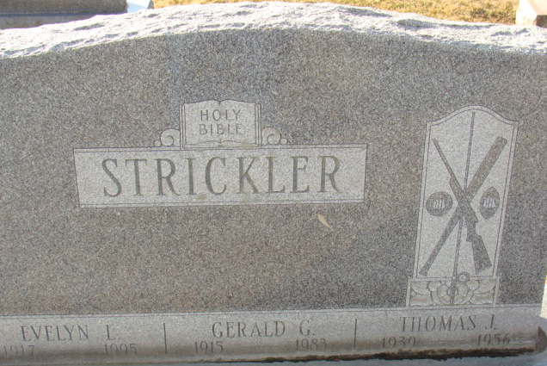
Photo by Alicia Kneuss

Decatur Youth Is Killed When Jeep Overturns
Thomas J. Strickler, 16, only son of Mr. and Mrs. Gerald S. Strickler of Decatur Route Four, was killed at about 11:20 a.m. Saturday in a traffic accident two miles south and three-fourths of a mile west of Decatur. Strickler died almost instantly of a crushed chest when the jeep which he was driving overturned after going out of control on a county road. Four young passengers in the jeep escaped serious injury.
Strickler was not far from his home on U.S. Highway 27 when the trailer which the jeep was pulling went off the road on the right side. The vehicle traveled about 200 feet in the ditch while Strickler fought to bring it under control. When he finally wheeled the vehicle onto the road, the jeep turned over. Strickler was thrown underneath and the vehicle fell on top of him, crushing his chest and his knee.
All four passengers were stunned but none sustained any serious injuries. They included Tom's sister, Carolyn Sue, 13; his cousin, Clayton Strickler, 13, son of Mr. and Mrs. Harold Strickler of Decatur, and two Fort Wayne boys, James Homan, 10, and his nine-year-old brother, Richard.
Clayton was taken to the hospital for observation and the others suffered only minor bruises. Carolyn was the first to regain consciousness after the accident and she went to a nearby farmhouse to report the accident. An ambulance was called but the Strickler boy was dead when help arrived at the scene.
The tragedy was Adams County's second traffic fatality of the year. The victim, whose father is a well-known auctioneer and realtor, was a popular member of the Decatur High School student body.
Born Oct. 28, 1939, in Decatur, his parents were Gerald S. and Evelyn Kohls-Strickler. Both survive. The youth was a member of the First Christian Church and a junior at D.H.S. He was active in athletics and was a member of the high school football and basketball teams.
Surviving in addition to the parents are two sisters, Sandra Lou and Carolyn Sue, both at home, and the grandparents, Mr. and Mrs. James C. Strickler of Decatur and Mr. and Mrs. William Kohls, also of Decatur.
Funeral services were conducted at 1:30 p.m. today at the First Christian Church, with the Rev. Traverse Chandler officiating. Burial was in the Decatur Cemetery. The funeral was directed by Black's Funeral Home, where friends called over the weekend. Members of the football team served as pallbearers at the funeral and took care of flowers. The entire junior class attended the funeral. The body was taken from Black's Funeral Home at noon to the church where it lay in state until the funeral.
Adams County Historical Museum, Adams County, Indiana
March 1955 – April 1958 Scrapbook, image 61
Handwritten date: Monday, September 10, 1956

