Ruth P. (Hammond) Strickler
July 23, 1910 – July 30, 1992

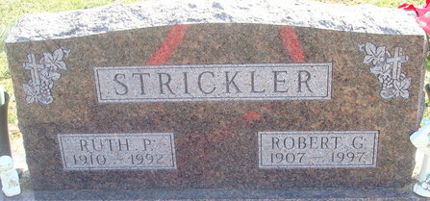
Photo by Alicia Kneuss

Ruth P. Strickler, 82, 1109 Angus Dr., died at 2:45 p.m. Thursday in Lutheran Hospital, Fort Wayne. She was born on July 23, 1910 in Scottville, Michigan to Fred E. and Lillie M. Whitright Hammond and married Robert G. Strickler on June 27, 1931. He survives.
A sales clerk for many years at the Jani Lyn store in Decatur, she was a member of Decatur Church of God and its Women's Missionary Society. She taught children's Sunday School at the church for many years. She was a member of the Decatur Business and Professional Women's Club and a volunteer worker at Adams County Memorial Hospital and Lakeside Manor.
Other survivors are two sons, Robert A. Strickler, Decatur, and Roger Strickler, Huntington; three daughters, Mrs. Riley (Sharon) Vian, Fort Wayne; Mrs. Joe (Carolyn) Ditto, Luguna Niguel, California; and Vicki J. Strickler, Decatur; a brother, Robert E. Hammond, Decatur; a sister, Revia Olson, Decatur; 12 grandchildren; and 10 great-grandchildren.
Funeral services will be at 2 p.m. Monday in Decatur Church of God, Revs. Kenneth Mishler and Ed Lovelace officiating. Burial will be in Decatur Cemetery. Pallbearers will be Steven Strickler, Scott Strickler, Todd Waymire, Brent Vian, Shane Strickler, Scott Shaw, Dan Shaffer, and Kim Pedler. Honorary pallbearers will be Janice Agler, Edith Chronister, Emma Frank, Flossie Hawkins, Betty Scott, and Bonnie Watkins.
Visiting hours are 10 a.m.-1 p.m., 3-5 p.m., and 7-9 p.m. Sunday at Haggard and Armes Funeral Home and 1-2 p.m. Monday in the church.
Preferred memorials are to Decatur Church of God's Women's Missionary Society.

Decatur Daily Democrat, Adams County, Indiana
July 31, 1992

