Ruby L. (Harvey) Strickler
November 17, 1893 – July 30, 1990

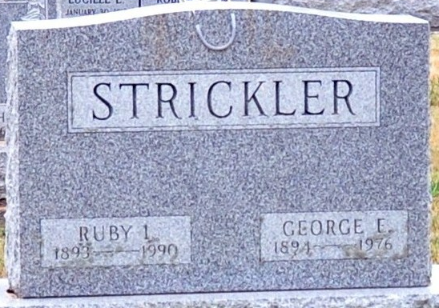
Photo by Deb Curry

Ruby L. Strickler, 96, a resident of route 4, Decatur for 60 years, died at 7:50 a.m. Monday in Chalet Village, Berne, her residence since 1985. She was in failing health for several years.
She was born on November 17, 1893, in Tipton, Indiana to John and Louisa Evans Harvey and married George F. Strickler (sic; should be George E.) on April 20, 1912. He died on April 2, 1976 (sic; should be 12th).
She was a homemaker and active member of Decatur Church of God, and was the oldest member of the church.
Surviving are one son, Roy E. Strickler, 206 N. 16th St.; one daughter, Mrs. Herbert (Dortha) Lengerich, route 1, Monroe; seven grandchildren; 22 great-grandchildren; and 19 great-great-grandchildren. Two sisters, Verna Ploughe Nelson and Iva Nidlinger; three brothers, Ray, Claude, and George Harvey; and one grandson are deceased.
Funeral services will be at 11 a.m. Friday in Decatur Church of God, Rev. Kenneth Mishler officiating. Burial will be in Decatur Cemetery. Visiting hours at Zwick-Sefton and Jahn Funeral Home are 7-9 p.m. Wednesday and 2-5 and 7-9 p.m. Thursday; there is visitation from 10-11 a.m. Friday at the church.
Preferred memorials are to the church.

Decatur Daily Democrat, Adams County, Indiana
Tuesday, July 31, 1990

