Roy E. Strickler
May 11, 1916 – May 5, 1994

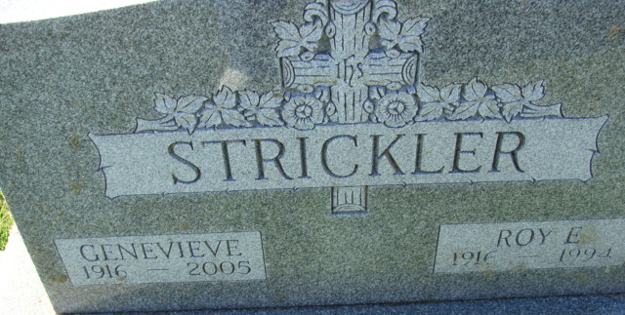
Photo by Alicia Kneuss

Roy E. Strickler, 77, 206 N. 16th St., died at 7:05 p.m. Thursday at home after a long illness. He was born on May 11, 1916 in Celina, Ohio to George and Ruby L. Harvey Strickler and married Genevieve L. Smith on July 9, 1936. She survives.
He formerly owned and operated Strickler Auto Sales at 8th and Monroe Sts., retiring in 1970, Prior to entering the auto business, he owned and operated Connie's Market, south of Decatur. He was a member of Decatur Church of God and was a former Sunday School superintendent.
Other survivors are two daughter, Mrs. Glen (Connie) Bowen, Van Wert, Ohio, and Mrs. Ed (Rita) Hirschy, Decatur; two sons, Glen and Rex Strickler, both of Decatur; 13 grandchildren; and 10 great-grandchildren. A sister, Dortha Lengerich, is deceased.
Funeral services will be at 2:30 p.m. Monday in Decatur Church of God, with burial in Decatur Cemetery. Visiting hours are 11 a.m. - 4 p.m. and 6-9 p.m. Sunday in Zwick-Sefton and Jahn Funeral Home, Decatur, and 1:30-2:30 p.m. Monday in the church.
Preferred memorials are to Adams County Home Health Care or the church.

Decatur Daily Democrat, Adams County, Indiana
Friday, May 6, 1994

