Robert G. Strickler
December 3, 1907 – July 13, 1997

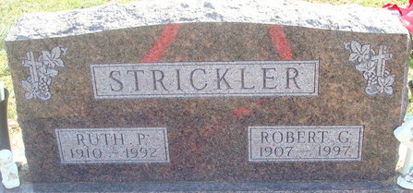
Photo by Alicia Kneuss

Robert G. Strickler, 89, died Sunday at Adams County Memorial Hospital. He retired in 1969 from the engineering department at International Harvester in Fort Wayne and was a World War II Army veteran. His wife, Ruth, died in 1992.
Surviving are two sons, Robert A. of Decatur and Roger "Rocky" of Huntington; three daughters, Sharon Vian of Fort Wayne, Carolyn Ditto of Laguna Niguel, Calif., and Vicki J. Strickler of Lima, Ohio; a brother Paul E. of Decatur; 12 grandchildren; and 17 great-grandchildren.
Services at 11 a.m. Wednesday at Decatur Church of God. Calling from 2 to 4 and 6 to 8 p.m. today at Haggard & Armes Funeral Home, and an hour before services at the church. Burial in Decatur Cemetery, with military graveside rites by Adams American Legion Post No. 43.
Memorials to Robert G. Strickler Memorial Fund at the church.

Journal Gazette, Allen County, Indiana
Tuesday, July 15, 1997
**
Indiana, U.S., Death Certificates, 1899-2017
Name Robert G. Strickler
Gender Male
Race White
Marital Status Widowed
Age 89
Birth Date 3 Dec 1907
Birth Place Decatur, Indiana
Death Date 13 Jul 1997
Death Place Decatur, Adams, Indiana, USA
Death Registration Date 1997
Father C. Gilbert Strickler
Mother Golda Shoaf
Informant Robert A. Strickler; son; Decatur, Indiana
Burial July 16, 1997; Decatur Cemetery; Decatur, Indiana

