Richard L. Strickler
November 9, 1926 – July 10, 2006

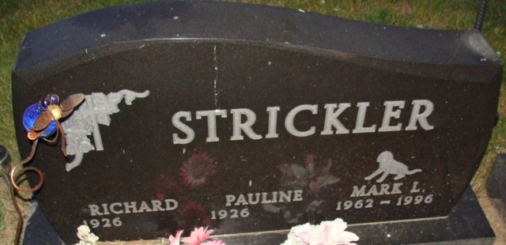
Photo by Alicia Kneuss

Richard L. Strickler, 79 years old of Middle Point, Ohio, passed away at 7:15 p.m. on Monday, July 10, 2006 in the Celina Manor located in Celina, Ohio. Richard was born on November 9, 1926 in Decatur, Indiana, the son of the late Hobart Strickler and the late Esther (August). He married Pauline Smith on November 15, 1947, and she survives.
Richard was a member of the American Legion Homer Pierson Post 207 in Willshire, Ohio. He served his country in the United States Navy during World War II, where he was stationed in Hawaii. Richard was employed by CASAD Depot, where he was a fireman, checker, and worked in maintenance; retiring on March 30, 1984 after 36 years of service.
Surviving are his wife, Pauline Strickler of Middle Point, Ohio, son, Barry Strickler of Middle Point, Ohio, son, Doug A. Strickler of Coldwater, Ohio, three grandchildren, and five great-grandchildren.
Preceding Richard in death were one son, Mark Strickler in 1996; and two grandchildren, Eric and Hollie Strickler.
Funeral services will be held at 3:00 p.m. Thursday, July 13, 2006 in the Zwick & Jahn Funeral Home with the Rev. Robert Shook officiating. Interment will follow in the Decatur Cemetery, Decatur, Indiana. Friends will be received from 2:00 p.m. - 3:00 p.m. Thursday, July 13, 2006 in the Zwick and Jahn Funeral Home, Decatur, Indiana. Preferred memorials are to Alzheimer's Association of Greater Indiana.

Zwick & Jahn Funeral Home, Adams County, Indiana
July 11, 2006

