Paul E. Strickler
April 23, 1916 – December 31, 2010

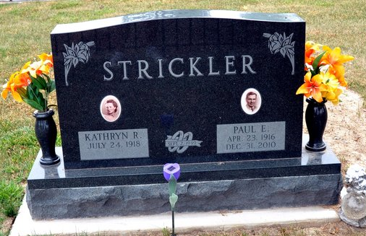
Photo by Deb Curry
PAUL E. STRICKLER, 94, of Decatur, passed away at 10:24 a.m. on Friday, Dec. 31, 2010 at his residence. Born April 23, 1916, to the late Clarence G. and Goldie G. (Shoaf) Strickler. Paul, in Adams County, Ind., he married Kathryn R. (Pyle) Strickler on September 2, 1939; she survives.
He and his wife Kathryn, were co-owners of Adams County Trailer Sales Inc., Strickler Trailer Court, Oakridge Estates, and Strickler Family Enterprises. He served on the Board of Governors of the Mobile Home Association and won several top selling awards in the mobile home industry. He was a member The Decatur Church of God, where he was Trustee. He was one of the original founders and past Chairman of the Board for Decatur Bank & Trust (now First Merchants Bank). He was instrumental in the organization of Decatur's Industrial Park and also Christmas lights in the downtown district. He was also a member of the Economics Commission that worked to entice new industry to Decatur. Paul and Kathryn were dual recipients of Stephen Decatur Award. They were the primary contributors to the Paul and Kathryn Strickler Cancer Institute at Adams Memorial Hospital. He served on the Board at Anderson University and he was a founder and lifelong member of the Decatur Optimist Club. He was also a member of the Decatur Masonic Lodge 571 F. & A.M.
He is survived by daughters, Cassandra K. Sanderson, Paula J. (Ben) Eliseo and Cynthia L. (Doug) Rieth all of Decatur; son-in-law, Duane Lee of Bradenton, Fla.; 21 grandchildren; 40 great grandchildren; three great-great-grandchildren. He was preceded in death by a daughter, Deborah Lee; two brothers, Clarence and Robert Strickler.
Funeral Service is 2 p.m. Wednesday, Jan. 5, 2011, at Decatur Church of God, with calling one hour prior to the service. Officiating will be Dr. Robert Brink. Visitation will be from 2 to 8 p.m. on Tuesday, Jan. 4, 2011, at Haggard & Sefton Funeral Home. An Optimist Memorial Service will be held at 8 p.m. followed by a Masonic Service at 8:15 p.m. Burial will be in Decatur Cemetery. Memorials may be made to Decatur Church of God or the Strickler Cancer Institute.
Fort Wayne (Allen County, IN) Newspapers
January 2, 2011

