Mary Jane (Thatcher) Strickler
August 26, 1858 – February 3, 1934

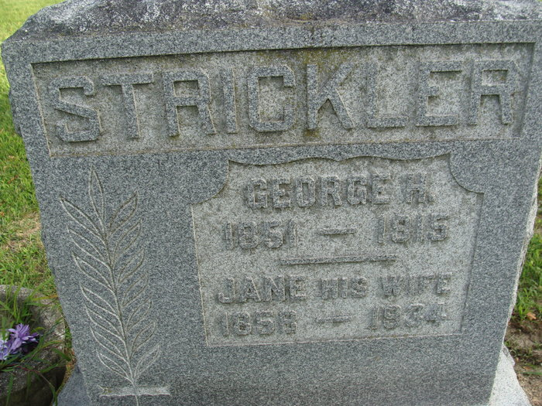
Photo by Alicia Kneuss

MRS. STRICKLER DIED SATURDAY
Mrs. Jane Strickler Died Saturday Afternoon at Home Here
Mrs. Jane Strickler, 75, well known resident of Decatur for many years, died at her home at 835 Mercer Avenue, Saturday afternoon at 2:15 o'clock following an extended illness. Death was due to complications. Mrs. Strickler had been ailing for the last 10 years following a stroke of paralysis.
She was born in Van Wert County, Ohio, on August 26, 1858, a daughter of Mr. and Mrs. Phillip Thatcher. On September 2, 1875 she was united in marriage to George H. Strickler, who preceded her in death June 25, 1915.
Surviving are three sons, Lawrence, Decatur; George E. of near Monroe and one daughter, Laura Strickler, at home.
Two sisters, Mrs. Samantha Barnett, Mercer Avenue, Mrs. Amanda Ross of near Willshire, Ohio, and a sister-in-law, Mrs. Mary Roop of Willshire, Ohio, also survive. Seven grandchildren and two great grandchildren also survive.
Mrs. Strickler was a member of the local Church of God.
Funeral services will be held Tuesday morning at 10 o'clock at the home on Mercer Avenue, and at 10:30 o'clock at the Church of God, with the Rev. Glen Marshall officiating. Burial will be made in the Decatur Cemetery.
The body was removed to the home from the S. E. Black Funeral Home Sunday afternoon.

Decatur Daily Democrat, Adams County, Indiana
Monday, February 5, 1934
**
Indiana, U.S., Death Certificates, 1899-2017
Name Jane Strickler
[Jane Thatcher]
Gender Female
Race White
Marital Status Widowed
Age 75
Birth Date 26 Aug 1858
Birth Place Indiana
Death Date 3 Feb 1934
Death Place Decatur, Adams, Indiana, USA
Death Registration Date 1934
Father Philip Thatcher
Mother Margaret Roop
Informant Lawrence Strickler
Burial February 6, 1934; Decatur Cemetery

