Mark L. Strickler
March 21, 1962 – January 15, 1996

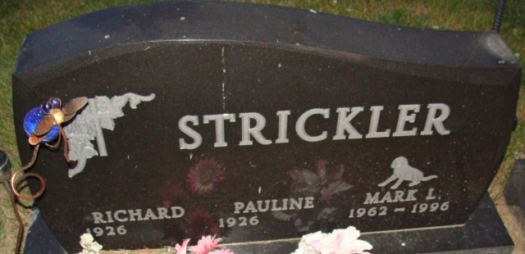
Photo by Alicia Kneuss

Ohio Deaths, 1908-1944 and 1958-2002 Record
Name: Mark Strickler
Birth Date: 21 Mar 1962
Birth State: Indiana
Gender: Male; Race: White;
Death Date: 15 Jan 1996
Death Time: 11:53 AM
Hospital of Death: Mercer Co Joint Twnshp Comm
County of Death: Mercer
Certificate: 005354
Age at Death: 33
Hospital Status: Hospital/D.O.
SSN: xxx
Father's Surname: Strickler
Mother's Maiden Name: Smith
Marital Status: Never Married
Education: 12
Armed Forces Indicator: No
Industry of Decedent: Water supply and irrigation
Occupation of Decedent: Water and sewage treatment plant operators
Primary Registration District: 5400
Source Citation: Certificate: 005354
Volume: 30547

