Mabel F. (Dunifon) Strickler
September 6, 1901 – December 23, 1994

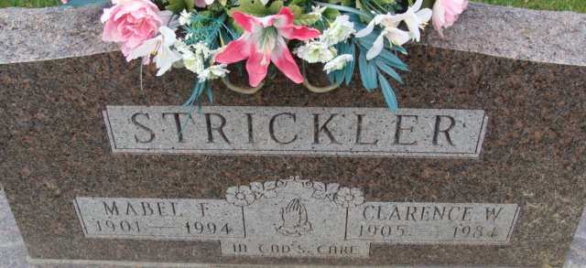
Photo by Alicia Kneuss

Mabel F. Strickler, 93, 409 Dormac St., died at 12:45 p.m. Friday in Adams County Memorial Hospital. She was born on September 6, 1901 in Van Wert, Ohio to Nathan and Sarah A. Roush Dunifon and married C. W. Strickler on Dec 26, 1925. He died on February 13, 1984.
She was a retired registered nurse, a graduate of Lutheran College of Nursing at Lutheran Hospital in Fort Wayne, and a member of Decatur Church of God, the Women of the Church of God, and the Adams County Retired Nurses' Association.
Surviving are a son, Larry Strickler, Payne, Ohio; a daughter, Mrs. Kenneth (Bonnie) Watkins, Decatur; a sister, Ethel Wallace, Van Wert; four grandchildren; and six great-grandchildren. Three brothers are deceased.
Funeral services will be at 11 a.m. Tuesday in Decatur Church of God, with burial in Decatur Cemetery. Visiting hours are 2-5 and 7-9 p.m. Monday in Haggard and Armes Funeral Home, Decatur, and 10-11 a.m. Tuesday in the church. Preferred memorials are to the Women of the Church of God.

Decatur Democrat, Decatur, Adams County, Indiana
Saturday, December 24, 1994
**
Indiana, U.S., Death Certificates, 1899-2017
Name Mabel F Strickler
[Mabel F Dunifon]
Gender Female
Race White
Marital Status Widowed
Age 93
Birth Date 6 Sep 1901
Birth Place Van Wert, Ohio
Death Date 23 Dec 1994
Death Place Decatur, Adams, Indiana, USA
Father Nathan Dunifon
Mother Sarah A Roush
Informant Bonnie Watkins; daughter; Decatur, Indiana
Burial December 27, 1994; Decatur Cemetery; Decatur, Indiana

