Lois M. (Barkley) Strickler
February 16, 1931 – May 17, 1996

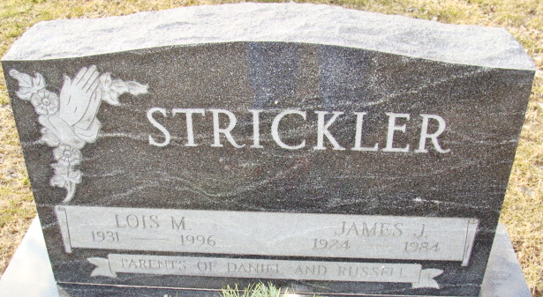
Photo by Alicia Kneuss

Lois M Strickler
in the Indiana, U.S., Death Certificates, 1899-2017
Name Lois M Strickler
[Lois M Barkley]
Gender Female
Race White
Marital Status Widowed
Age 65
Birth Date 16 Feb 1931
Birth Place Van Wert County, Ohio
Death Date 17 May 1996
Death Place Decatur, Adams, Indiana, USA
Death Registration Date 1996
Father Orley S Barkley
Mother Garnetta G Arnold
Informant Daniel G. Strickler; son; Decatur, Indiana
Burial May 19, 1996; Decatur Cemetery; Decatur, Indiana

