Lena S. (Cook) Strickler
August 30, 1885 – July 16, 1967

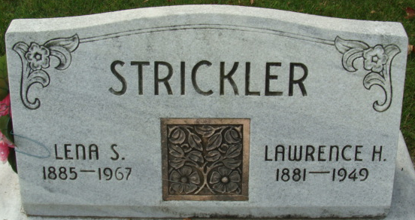
Photo by Alicia Kneuss

MRS. LENA STRICKLER DIES LAST EVENING
Mrs. Lena Strickler, 81, of 611 Winchester Street, died at 5:15 p.m. Sunday at the Adams County Memorial Hospital. She had been in failing health for several months.
She was born in Washington Township on Aug. 30, 1885, a daughter of Flora and Alice Tippy-Cook, and had lived in Decatur since 1949. Her husband, Lawrence H. Strickler, to whom she was married Dec. 23, 1906, preceded her in death July 9, 1949.
Mrs. Strickler was a member of Church of God.
Surviving are one daughter, Mrs. Herbert (sic) (Mildred) Keller of Decatur; one son, Lester E. Strickler of Indianapolis; six grandchildren; four great-grandchildren; and two sisters, Mrs. Frank (Nola) Haggard of Fort Wayne, and Mrs. Danny (Beulah) Lyons of Anderson. One daughter, two brothers and one sister are deceased.
Funeral rites will be held at 1:30 p.m. Wednesday at the Zwick Funeral Home and at 2 p.m. at the Church of God, with Rev. Sylvester Martin officiating. Burial will be in the Decatur Cemetery. Friends may call at the funeral home from 7 to 10 p.m. today and from 4 to 10 p.m. Tuesday.

Decatur Daily Democrat, Adams County, Indiana
Monday, July 17, 1967

