Lawrence H. Strickler
February 1, 1881 – July 9, 1949

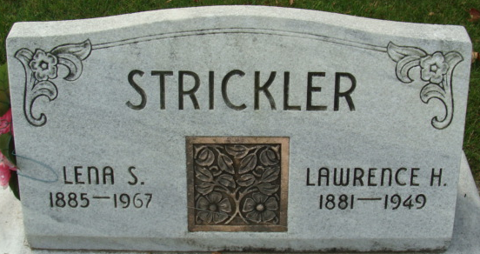
Photo by Alicia Kneuss

LAWRENCE STRICKLER DIES SATURDAY NIGHT
Funeral Services Tuesday Afternoon
Lawrence H. Strickler, 68, retired farmer of south of Decatur, died at 10:15 o'clock Saturday night at the Adams County Memorial Hospital after an illness of several years.
A lifelong resident of Adams County he was born in St. Mary's Township Feb. 1, 1881, a son of George and Jane Thatcher-Strickler. He was married to Lena Cook Dec. 23, 1906.
He was a member of the Church of God.
Surviving in addition to his wife are a daughter, Mrs. Hubert Keller of Decatur; a son, Lester of Indianapolis; six grandchildren; two brothers, Gilbert Strickler of Decatur and George of Monroe, and one sister, Miss Laura Strickler of Decatur. One daughter preceded him in death.
Funeral services will be held at 1:30 p.m. Tuesday at the Zwick Funeral Home and at 1:45 o'clock at the Church of God, the Rev. Dwight R. McCurdy officiating. Burial will be in the Decatur Cemetery. Friends may call at the funeral home until time of the services.

Decatur Daily Democrat, Adams County, Indiana
Monday, July 11, 1949

