Laura C. (Wolfe) Strickler
May 24, 1891 – November 10, 1970

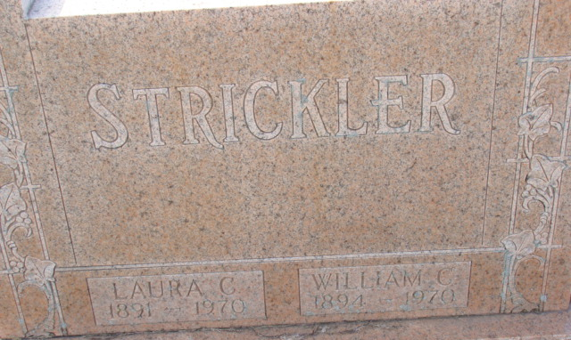
Photo by Alicia Kneuss

Laura C Strickler
in the Indiana, U.S., Death Certificates, 1899-2017
Name Laura C Strickler
[Laura C Wolfe]
Gender Female
Race White
Marital Status Widowed
Age 79
Birth Date 24 May 1891
Birth Place Indiana
Death Date 10 Nov 1970
Death Place Portland, Jay, Indiana, USA
Death Registration Date 1970
Father Daniel Wolfe
Mother Ellen [Moore]
Informant Robert M. Strickler; son; Portland, Indiana
Burial November 12, 1970; Decatur Cemetery; Decatur, Indiana

