Laura A. Strickler
April 1, 1887 – January 18, 1970

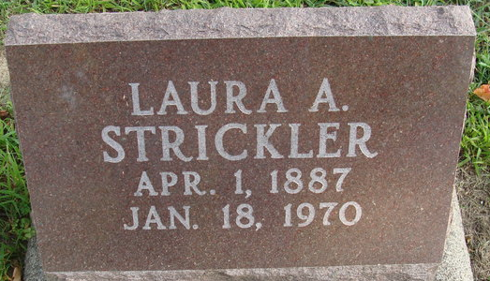
Photo by Alicia Kneuss

LAURA A. STRICKLER DIES AT HOSPITAL
Miss Laura A. Strickler, 82, of 835 Mercer Avenue, a former employee of the Adams County Memorial Hospital, died at 2:45 p.m. Sunday at the hospital following an extended illness. Her condition had been critical for the past week.
Born near Willshire, O., April 1, 1887, she was a daughter of George H. and Jane Thatcher-Strickler.
Miss Strickler was a charter member of the Decatur Church of God, and an honorary member of the Women's Missionary Society.
Surviving are a brother, George E. Strickler of Monroe, and several nieces and nephews. Two brothers are deceased.
Funeral services will be conducted at 2:30 p.m. Tuesday at the Church of God, with Rev. James E. Johnson officiating. Burial will be in the Decatur Cemetery. Friends may call at the Winteregg-Linn Funeral Home from 7 p.m. today until 11:30 a.m. Tuesday, and at the church from 12 noon until time of the services.
Decatur Daily Democrat, Adams County, Indiana
Monday, January 19, 1970

**
DECATUR, Ind. – Funeral services were to have been held today for Miss Laura A. Strickler, 82, of Decatur, at the Decatur Church of God, with the Rev. James E. Johnson officiating. Burial was to have been in the Decatur Cemetery.
Mrs. Strickler died at 2:45 p.m. Sunday in Adams County Memorial Hospital following an extended illness. Her condition had been critical for the past week.
Born near Willshire, April 18, 1887, she was a daughter of George H. and Jane (Thatcher) Strickler.
She was a former employee of the Adams County Memorial Hospital and a charter member of the Decatur Church of God, where she was an honorary member of the Women's Missionary Society.
Her only immediate survivor is a brother, George E. of Monroe, Ind.
Times Bulletin, Van Wert County, Ohio
Tuesday, January 20, 1970

