Kathryn R. (Pyle) Strickler
July 24, 1918 – December 31, 2013

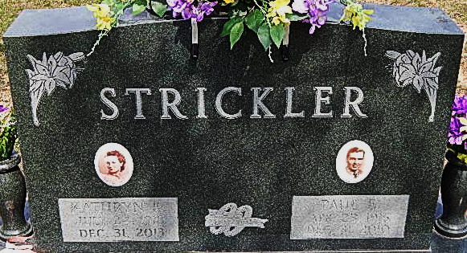
Photo by Alicia Kneuss

Kathryn R. Strickler, 95, of Decatur died at her residence Tuesday, December 31, 2013. Kathryn was born in Geneva, IN to the late Elmer and Opal (Cole) Pyle. She married Paul E. Strickler on September 2, 1940. He preceded her in death on December 31, 2010.
Kathryn was a member of Decatur Church of God, where she had taught Sunday school for 35 years and was on the Board of Trustee's and also on the building committee of the church and was co-owner of Adams County Trailer Sales Inc.
She was active in the Research Club, Root Township Home Ec. Club, Business and Professional Women's Club of which she was named Women of the Year, Daughters of American Revolution, she started the Adams Memorial Hospital Auxiliary where they raised money for purchasing new equipment for the hospital and also started the gift shop. She was also a member of Key 73 and was awarded the co-Stephen Decatur Award along with her husband in 2002.
Kathryn is survived by three daughters Cassandra K. Sanderson, Paula (Ben) Eliseo and Cynthia (Douglas) Rieth all of Decatur, IN; 18 grandchildren and 34 great grandchildren. She is preceded in death by a daughter Deborah A. Lee.
Unknown source
**
Indiana, U.S., Death Certificates, 1899-2017
Name Kathryn R Strickler
Maiden Name Pyle
Gender Female
Race White
Age 95
Birth Date 24 Jul 1918
Birth Place Geneva, Indiana
Death Date 31 Dec 2013
Death Place Decatur, Adams, Indiana, USA
Father Elmer Pyle
Mother Opal Cole
Informant Cassandra K. Sanderson; daughter; Decatur, Indiana
Burial Decatur Cemetery; Decatur, Indiana
Certificate Number 059936

