Kathleen Strickler
April 10, 1936 – April 10, 1936

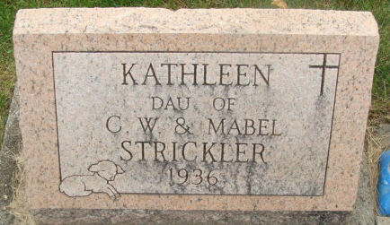
Photo by Alicia Kneuss

Handwritten date: Friday, April 10, 1936
A daughter, Kathleen, born to Mr. and Mrs. Clarence Strickler at the Adams County Memorial Hospital this morning died at 3:30, shortly after birth.
Surviving besides the parents are the grandparents, Mr. and Mrs. C. G. Strickler and Mr. and Mrs. N. E. Dunnafon (sic; should be Dunifon) and a sister, LaVon.
The body will be taken from the Black funeral home to the C. G. Strickler residence, 734 Mercer Avenue, this afternoon. Funeral services will be conducted Saturday at 2:30 p.m. by Rev. Glen Marshall and burial will be in Decatur Cemetery.
Unknown source
Handwritten date: Friday, April 10, 1936
**
Indiana, U.S., Birth Certificates, 1907-1940
Name: Kathaleen Strickler; premature; born alive but now dead
Gender: Female
Birth Date: 10 Apr 1936
Birth Place: Decatur, Adams, Indiana, USA
Registration Year: 1936
Father: Clarence Strickler; age 30
Mother: Mabel Dunifonn; age 34; 2nd child born; 1 now living
Certificate Number: 13827
Roll Number: 006
Agency: Indiana State Board of Health
Volume Range: 26 30

