James J. Strickler
June 24, 1924 – June 27, 1984

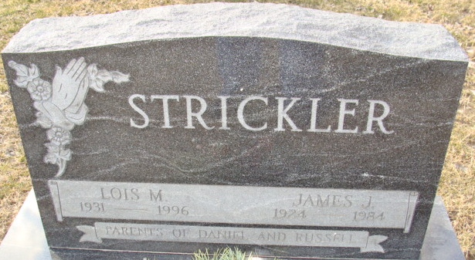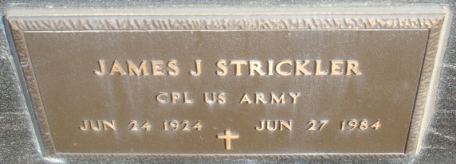
Photo by Alicia Kneuss

James J. Strickler
in the Indiana, U.S., Death Certificates, 1899-2017
Name James J. Strickler
Gender Male
Race White
Marital Status Married
Age 60
Birth Date 24 Jun 1924
Birth Place Indiana
Death Date 27 Jun 1984
Death Place Decatur, Adams, Indiana, USA
Death Registration Date 1984
Father James C. Stickler
Mother Edna Durr
Spouse Lois M. Barkley
Informant Lois M. Strickler; wife; Decatur, Indiana
Burial June 30, 1984; Decatur Cemetery; Decatur, Indiana

