Hollie Renee Strickler
December 14, 1972 – July 17, 2005

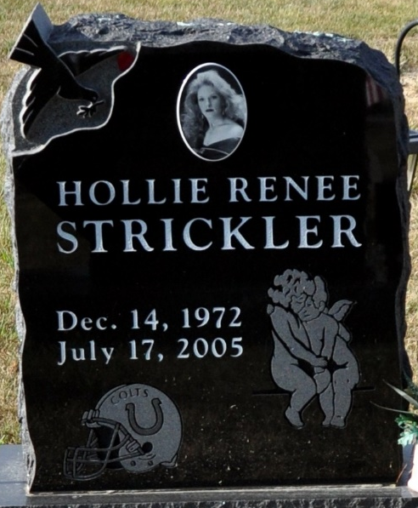
Photo by Deb Curry

Hollie R. Strickler of Decatur, died Sunday July 17, 2005 at her residence. She was the daughter of Barry Strickler and Vicki (Anderson) Rutherford. Hollie was employed at Fleetwood Motors in the final inspector area. She also worked for Famous Hair and Ideal Reality.
Surviving are her father and stepmother Barry & Kim Strickler of Middle Point, Ohio; her mother and stepfather Vicki & Rick Rutherford of Decatur; a sister Mrs. Brien (Tammy) Corzine of Middle Point; a step sister Mrs. Joseph (Tracy) Martino of Kokomo; 3 step brothers Errick, Derrick, Zackery Rutherford all of Kokomo and Grandparents Florene "Pat" Anderson of Decatur; Richard & Pauline Strickler of Celina, Ohio and Glenn & Joann Neer of Middle Point, Ohio.
Preceded Hollie in death was a brother Eric D. Strickler on May 4, 1991. Hollie was a former member of the Middle Point United Methodist Church in Middle Point, Ohio.
Visitation will be on Wednesday, July 20, 2005 from 2-7 pm at Haggard & Sefton Funeral Home. Funeral will be on Thursday, July 21, 2005 at 2:30 pm also at the funeral home. Rev. Cindy Lumm will be officiating with burial in the Decatur Cemetery.
Memorials are to Middle Point United Methodist Church or Donors choice.

Haggard & Sefton Funeral Home, Adams County, Indiana
July 18, 2005

**
Indiana, U.S., Death Certificates, 1899-2017
Name Hollie R Strickler
Gender Female
Race White
Marital Status Divorced
Age 32
Birth Date 14 Dec 1972
Birth Place Van Wert, Co, Ohio
Death Date 17 Jul 2005; suicide by gun
Death Place Decatur, Adams, Indiana, USA
Death Registration Date 2005
Father Barry E Strickler
Mother Vicki A Anderson
Informant Vicki A. Rutherford; mother; Decatur, Indiana
Cremation July 22, 2005; Wilson Burial Vault; Huntington, Indiana

