Golda G. (Shoaf) Stricker
July 13, 1887 – August 6, 1977

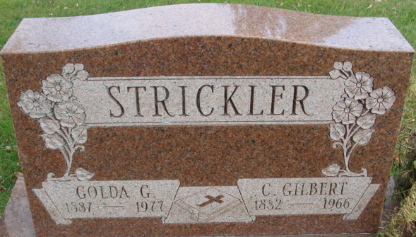
Photo by Alicia Kneuss

Goldie G. Strickler, 90, a resident of the Decatur Community Care Center, died Saturday at 3:50 p.m. at the Adams County Memorial Hospital, where she had been a patient for one day.
Mrs. Strickler was the last charter member of the Church of God and was also a member of the Women of the Church of God and the Adams County Home Economics Club. She was a former employe (sic) of the Adams County Memorial Hospital.
Born on July 13, 1887, near Curryville, Indiana, she was the daughter of Ambrose F. and Rosetta Snyder-Shoaf. She was married to C. Gilbert Strickler on October 9, 1904, and he preceded her in death on April 21, 1966.
Mrs. Strickler is survived by three sons, Clarence W., Robert G., and Paul E., all of Decatur; one sister, Mrs. Floyd (Ida) Shirk, Fort Wayne; one brother, Floyd Shoaf, Pinnellas Park, Florida; 11 grandchildren and 28 great-grandchildren. One brother, Roy Shoaf, preceded her in death.
Funeral services will be held at 2 p.m. Tuesday at the Church of God, the Rev. Russell M. Noss to officiate along with the Rev. Dewight L. McCurdy, former pastor here. Burial will be in the Decatur Cemetery. Friends may call at the Winteregg-Linn and Haggard Funeral Home tonight. The body will lie in state at the church from noon until time of services on Tuesday.

Decatur Daily Democrat, Adams County, Indiana
Monday, August 8, 1977

