Gerald G. Strickler
October 7, 1915 – May 19, 1983

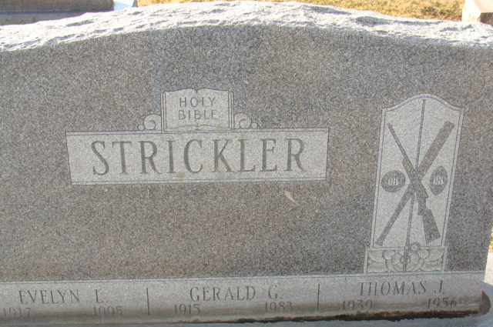
Photo by Alicia Kneuss

Gerald G. Strickler
in the Indiana, U.S., Death Certificates, 1899-2017
Name Gerald G. Strickler
Gender Male
Race White
Marital Status Married
Age 67
Birth Date 7 Oct 1915
Birth Place Indiana
Death Date 19 May 1983
Death Place Fort Wayne, Allen, Indiana, USA
Death Registration Date 1983
Father James C. Strickler
Mother Edna Durr
Spouse Evelyn Kohls
Informant Mrs. Gerald Strickler; Decatur, Indiana
Burial May 21, 1983; Decatur Cemetery; Decatur, Indiana

