George H. Strickler
June 12, 1851 – June 25, 1915

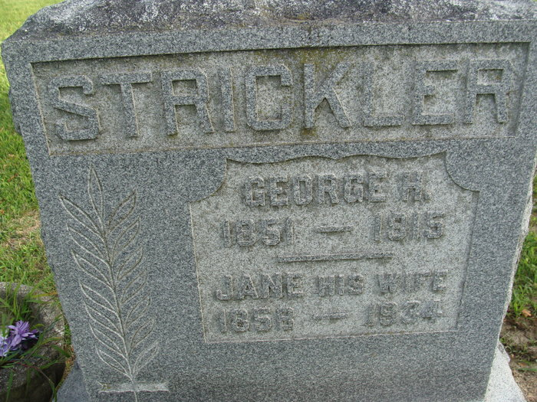
Photo by Alicia Kneuss

DEATH RESULTS
Runaway Accident of Over a Year Ago Causes Death of Geo. H. Strickler
WELL KNOWN MAN - Of Washington Township - This Morning -- Funeral Will Be Held Sunday
At ten minutes after seven o'clock this morning, George H. Strickler, a well-known and highly respected farmer, residing one mile east of the Brandyberry School in Washington Township, passed away, death being due to Bright's disease and complications. About a year ago while driving to this city, Mr. Strickler was a victim of a severe runaway accident in which he sustained injury to his liver and kidneys. As a result of these injuries, Bright's disease and other complications soon afterward developed and although the best medical services possible were secured, the disease continued to develop until death relieved the patient this morning.
Mr. Strickler was born in Indiana, June 12, 1851, being the son of Mr. and Mrs. John Strickler. The deceased was married in early manhood to Miss Elizabeth Miller and to this union were born four children, they being Lawrence, Gilbert of this city, Laura at home, and George E., Adams County. One sister, Mrs. Mary Roop, of Willshire, also survives.
Mr. Strickler was a resident of Adams County for the past ten years and was intimately known by many residents of the southern part of the county.
A short prayer service will be held at the home Sunday afternoon at 1:30 o'clock and at 3 o'clock services will also be held at the Church of God in this city, Ruby Walling of Willshire, Ohio, officiating. Interment will be made in the Maplewood Cemetery.

Decatur Daily Democrat, Adams County, Indiana
Friday, June 25, 1915
**
George H. Strickler was born Jan. 12th, 1851, in Adams County, Ind., and departed this life June 25, 1915, aged 64 years, 5 months and 13 days. He was one of a family of eleven children. All have preceded him in death but one sister, Mary Roop of Willshire, and one half-sister, Elizabeth McClellan of Reading, Mich. He was united in marriage September 2nd 1875, to Jane Thatcher. To this union were born four children: Lawerence (sic) of Monroe, Ind., Gilbert of Decatur, Ind., George E. of Salem and Laura who resides at home. He leaves a devoted wife, four children, five grandchildren and a number of brothers and sisters in the Lord and a host of neighbors and friends to mourn their loss.
He lived near Decatur, Ind., and Willshire, Ohio, nearly all his life. In the business world he was industrious and had the confidence of his fellowmen as an honest and upright man. He gave his heart to God over twenty years ago and left the testimony on his dying bed of his acceptance with Christ. In March 1914, he was hurt in a runaway in Decatur and never was very strong afterwards. Finally, a complication of Bright disease and dropsy set in which brought on his death.
He bore his long affliction with patience and Christian fortitude and slept away peaceably the way he often prayed to go.
He was laid away to rest in the Decatur Cemetery, Sunday afternoon. Evang. R. A. Walling officiated.
We desire to thank the many neighbors and friends for their kindness and assistance during the illness and death of my husband. Mrs. Jane Strickler and children.

Willshire Herald, Willshire, Van Wert County, Ohio
Thursday, July 1, 1915
**
In his will probated Friday, George H. Strickler leaves a life estate in his real and personal property to his widow, Jane Strickler. After her death the sum of fifty dollars is to go to the Church of God; the household furniture to his daughter, Laura; and the rest of the estate is to be divided equally among their four children, Lawrence, Gilbert, Laura and George E. He asks that John Chilcoat serve as executor. Mr. Chilcoat qualified giving $1,000 bond. - Decatur Democrat

Willshire Herald, Willshire, Van Wert County, Ohio
Thursday, July 8, 1915

**
Indiana, U.S., Death Certificates, 1899-2017
Name George H. Strickler
Gender Male; Race White
Marital Status Married
Age 64
Birth Date 12 Jun 1851; Birth Place Pennsylvania
Death Date 25 Jun 1915; Death Place Washington, Adams, Indiana, USA
Death Registration Date 1910-1919
Father John Strickler
Mother Elizabeth Miller
Informant J. W. Strickler; Decatur, Indiana
Burial June 28, 1915; Decatur, Indiana

