George E. Strickler
October 8, 1894 – April 12, 1976

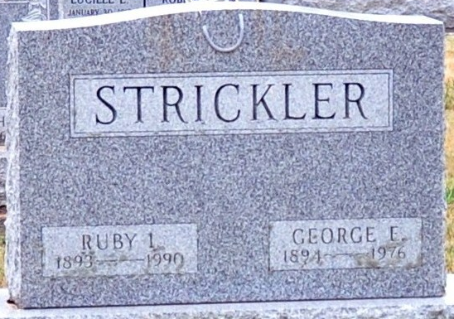
Photo by Deb Curry

GEORGE STRICKLER
George E. Strickler, 81, route 4, Decatur, died at 6:15 a.m., today at the Adams County Memorial Hospital, where he had been hospitalized eight weeks.
A member of the Church of God, he retired in 1950 after 30 years of employment with Standard Milling Co,, Kansas-St. Paul Milling Co., of St. Paul, Minn.
Mr. Strickler was born October 8, 1894 in St. Mary's Township to George H. and Jane Thatcher-Strickler, and was married April 20, 1912 to Ruby Harvey-Strickler, who survives. Also surviving are one son, Roy E. Strickler, of Decatur; one daughter, Mrs. Herbert (Dorothy) Lengerich of route 1, Monroe; eight grandchildren and 18 great-grandchildren. He was preceded in death by two brothers and one sister.
Funeral services will be held at 2 p.m. Wednesday at Winteregg-Linn & Haggard Funeral Home, Rev. Arthur Burnett and Rev. Mark Stayton in charge. Burial will be in the Decatur Cemetery. Friends may call at the funeral home after 1:30 p.m. Tuesday.
Preferred memorials are to the church or heart fund.

Decatur Daily Democrat, Adams County, Indiana
Monday, April 12, 1976

