Genevieve L. (Smith) Strickler
August 27, 1916 – September 1, 2005

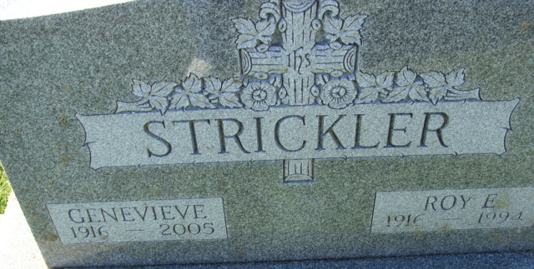
Photo by Alicia Kneuss

Genevieve L Strickler, 89 years old and a longtime resident of Decatur, Indiana, passed away on Thursday, September 1, 2005 at Swiss Village, Berne, Indiana where she had resided since April.
She was born on August 27, 1916 in Berne, Indiana the daughter of the late A. C. Smith and the late Emma (Bixler) Smith. She married Roy E. Strickler on July 9, 1936 in Berne. He passed away on May 5, 1994.
Genevieve was a member of the Decatur Church of God where she was involved with "The Forget Me Nots" of the church. She had worked at the family businesses, Connie's Market and Strickler Auto Sales.
Surviving are her daughter, Mrs. Glen (Connie) Bowen of Angola, Indiana, son, Glen Strickler of Decatur, Indiana, son, Rex "Rick" (Kathy) Strickler of Decatur, Indiana, daughter, Mrs. Ed (Rita) Hirschy of Decatur, Indiana, sister, Mrs. Arthur (Joyce) Anker of Fort Wayne, Indiana, thirteen grandchildren, twenty great-grandchildren, and one great-great grandchild.
Genevieve was preceded in death by one brother; Maurice Smith and one sister; Corine Miller.
Funeral services will be held at 2:30 p.m. Sunday, September 4, 2005 in the Decatur Church of God with Pastor Sandy Hildebrand officiating. Interment will follow in the Decatur Cemetery. Friends will be received from 2:00 p.m. to 5:00 p.m. and 6:00 p.m. to 8:00 p.m., Saturday, September 3 in the Zwick & Jahn Funeral Home, Decatur, Indiana.
Preferred memorials are to Decatur Church of God.

Zwick & Jahn Funeral Home, Adams County, Indiana
September 2, 2005

