Evelyn L. (Kohls) Strickler
November 24, 1917 – March 8, 1995

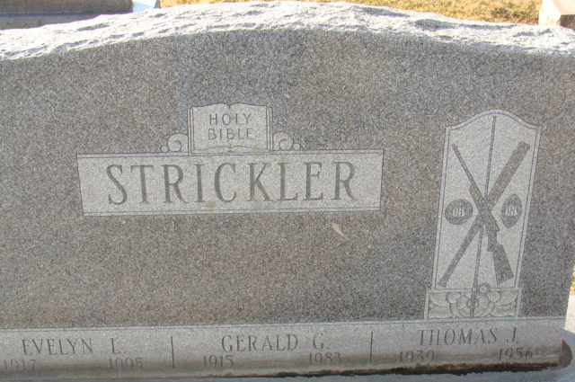
Photo by Alicia Kneuss

Evelyn L Strickler
in the Indiana, U.S., Death Certificates, 1899-2017
Name Evelyn L Strickler
[Evelyn L Kohls]
Gender Female
Race White
Marital Status Widowed
Age 77
Birth Date 24 Nov 1917
Birth Place Roanoke, Indiana
Death Date 8 Mar 1995
Death Place Decatur, Adams, Indiana, USA
Death Registration Date 1995
Father William F Kohls
Mother Florence Stump
Informant Sue Kelley; daughter; Decatur, Indiana
Burial March 10, 1995; Decatur Cemetery; Decatur, Indiana

