Eric D. Strickler
July 13, 1971 – May 4, 1991

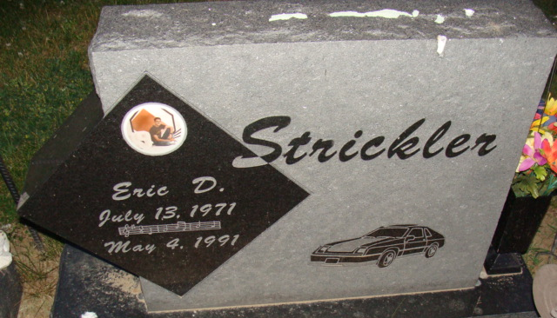
Photo by Alicia Kneuss

He was born on July 13, 1971 in Van Wert, Ohio to Barry E. and Vicki A. Anderson Strickler. His father and stepmother, Kimala, live in Middlepoint, Ohio; his mother resides on Route 5, Decatur. He was never married.
Mr. Strickler, a private in the Ohio National Guard Reserve, was a member of Middlepoint United Methodist Church.
Also surviving are two sisters, Hollie R. Strickler, Decatur; and Tamera J. Lee, Middlepoint; maternal grandmother, Florence R. Anderson, Decatur and paternal grandparents, Richard and Pauline Strickler, Ohio.
Funeral services are at 11 a.m. Wednesday in Haggard and Armes Funeral Home, with burial in Decatur Cemetery, including military graveside rites by the Ohio National Guard Reserve. Visiting hours are 2-5 and 7-9 p.m. Tuesday.

Decatur Daily Democrat, Adams County, Indiana
Monday, May 6, 1991

**
Indiana, U.S., Death Certificates, 1899-2017
Name Eric D Strickler
Gender Male
Race White
Marital Status Never Married (Single)
Age 19
Birth Date 13 Jul 1971
Birth Place Van Wert, Ohio
Death Date 4 May 1991
Death Place Decatur, Adams, Indiana, USA
Death Registration Date 1991
Father Barry E Strickler
Mother Vicki A Anderson
Informant Vicki Strickler; mother; Decatur, Indiana
Cremation May 9, 1991; Fort Wayne Crematory; Fort Wayne, Indiana

